# Task 4—Moving Debian 1 and 2 behind the firewall

Now you will move Debian-1 and Debian-2 behind the pfsense firewall. This would model how typical computers are configured in a business setting.

## Steps

1. From your Debian-1 VM change the network adapter to connect to **VMNet11**
   1. Player **Menu🡪Manage🡪Virtual Machine Settings**
   2. Select the **Network Adapter**
   3. Select the Custom: **Specific Virtual Network** radio button then choose, **VMNet11**
2. Now move **Debian-2** to **VMnet11** just as you did Debian-1
3. After you have moved both Debian-1 and Debian-2 to the new network complete the following table:

|  |  |  |
| --- | --- | --- |
| **VM** | **IP Address** | **MAC Address** |
| Debian-1 | 192.168.1.108 | 00:0c:29:73:aa:39 |
| Debian-2 | 192.168.1.109 | 00:0c:29:5e:c7:48 |

1. Compare the results from the previous exercise, did the IP addresses change for Debian-1 and 2? Yes the IP addresses change for both of the VM’s since they’re connected to the pfSense Local Area Network (LAN)
2. If by chance the IP addresses did not change on Debian-1 and Debian-2 you will need to restart the network. You can do this with the Wicd Network Manager. To open the Wicd Network Manager click on the start menu🡪Internet🡪Wicd Network Manager. You will use this tool to change network settings all semester learn to love it ☺.  
   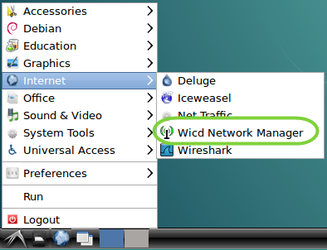
3. You should see something like this  
   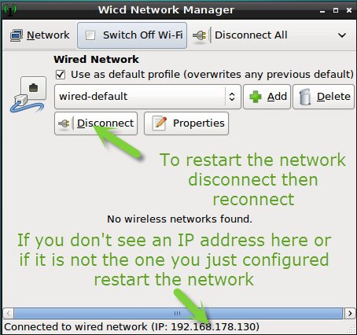
4. Click the Disconnect button, this will stop the network. The button will change to say connect, click it to start the network. When the button says connect it means the network is currently disconnected.

# Task 5—Exploring networks

In this task you will explore the network addresses for the VMs. In our lab thus far you can determine the network address from the IP address as follows. If you take the last number of the IP address and replace it with a 0 that is the network address. E.g. if your Debian 3 VM’s IP address is 192.168.100.101 then its network address would be 192.168.100.0.

## Steps

1. Complete the following table. Get the IP address from you VM, derive the network address instructed above.

|  |  |  |
| --- | --- | --- |
| **VM** | **IP address** | **Network address** |
| Debian-1 | 192.168.1.108 | 192.168.1.0 |
| Debian-2 | 192.168.1.109 | 192.168.1.0 |
| Debian-3 | 192.168.136.135 | 192.168.136.0 |
| pfsense WAN | 192.168.136.132 | 192.168.136.0 |
| pfsense LAN | 192.168.1.1 | 192.168.1.0 |

1. Now answer the following questions
2. Which VM(s) have the same network as the pfsense WAN network adapter? Debian3
3. Which VM(s) have the same network as the pfsense LAN network adapter? Debian1 and Debian2